FONTYS UNIVERSITY OF APPLIED SCIENCES HBO-ICT: English Stream

**Project Core Phase Project Plan Modular epidemiological hospital efficiency simulator**

Amin Masoumzadegan Jahromi

Danas Jusys

Dayana Naydenova

Edgaras Spiridonovas

Ella Seyedkabirian

Project leader: Mateusz Ulas

Tutor: Andrius Kuprys

Version: 0.5 Curriculum date: 2020 February – June

# Table Of Contents

1. Table Of Contents
2. Introduction
3. Simulation software proposition and justification
4. Project constraints and risks
5. MoSCoW method
6. Deliverables
7. Gantt chart
8. Work distribution and planning
9. REFERENCES

# Introduction

**Project client problem statement and client’s representative**

Curriculum structure, as stated in ProCP Workbook*, implies that SIM Software Inc. is requesting various project proposals in the area of simulation software. A list is provided for possible simulation domains, however our group will justify a need for a novel simulation model for contemporary events, relating to Covid-19 pandemic. Project length is set to one study semester. Communication with aforementioned enterprise will happen through assigned tutor Mr. Andrius Kuprys, a Fontys lecturer. Tutor feedback is crucial for the successful fruition of the project, and therefore will be available during mandatory weekly project meetings.

# Simulation software proposition and justification

It is assumed that the reader is aware of the current pandemic outbreak of Covid-19 respiratory virus. Although as students located in Western European country the Netherlands, we currently have the luxury of not having to react, it is naturally alarming that such pandemic events can happen seemingly spontaneously. World Health Organization director Tedros Adhanom Ghebreyesus, a leading authority on disease prevention, has tweeted on 2020-02- 08 that current global infection case count for Covid-19 might be “the tip of the iceberg” ** . Our group reasons that a simulation in the following problem domain is necessary, and will be a valuable asset to SIM Software Inc., especially in case of further global disease spread. To be more particular, we propose to gradually develop a simulation of efficiency of modular field hospital. Such structures were assembled in the Wuhan, Hubei – the epicenter of current outbreak. Namely those were Huoshenshan and Lishenshan modular hospitals, that were built according to previous practices used during ‘Severe Acute Respiratory Syndrome’ (SARS) outbreak back in 2003. A reader might recognize two aforementioned hospitals from news headlines, such as ‘the hospitals that were built in 10 days’.

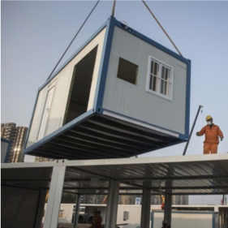

Fig 1. The Huoshenshan hospital

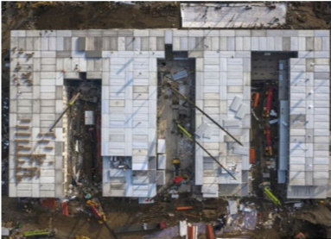

Fig 2. Areal view of Huoshenshan module being assembled. hospital.

Source bbc.com/news Field hospitals as temporary care units are used by majority of world’s militaries, for the purpose of providing medical support to injured staff here and now, before transferring patients 4 to permanent facilities 3 . A cheaper and more common option is to use tent like structures, that are a lot easier to assemble and move around. However, typical tent like temporary field hospitals does not fit the Wuhan’s case, and significant number of similar settings, because of several reasons. Firstly, average temperature for the region during mid-late winter is around 4 degrees Celsius 4 . Secondly, easily movable tent-like structure might not be sufficient for containment and isolation purposes. Third, consistent reliable electrical power is required for specific supportive care operations, especially during late respiratory complication phase. Fourth, leading scientists can not say with absolute certainty whether the virus is spreading through droplets or is airborne, therefore a filtering system is needed. All this should prove the statement, that although there is a history of cheap and efficient field hospitals, stemming from military tradition, modern diseases require more sophisticated building structures in order to provide adequate care. Our group will deliver a product which would allow efficiency simulation of such modular field hospitals in specified region. Given two initial parameters, population size of specified area and specified spending budget, our simulation would estimate whether the specified spending budget would be sufficient to ensure best possible medical care to infected people from that specified area. Estimation could either inform whether specified monetary amount would be exceeding what is actually needed, or whether specified monetary amount would not be sufficient to fully care for the location. In case of our algorithm producing ‘insufficient funding’ output, a simulation could also unveil at which crucial breaking point, hospital was overloaded. This information is useful to any government branch, responsible for fund allocation for disaster prevention and treatment. For instance, it could be used by ‘Rijksinstituut voor Volksgezondheid en Milieu’ in the Netherlands, or European Centre for Disease Prevention and Control across the continent. Of course it would be an attractive software tool for those municipalities, that considered what sort of prevention should be in place for their cities and towns, also here in the Netherlands. This completes selected real-life system simulation justification, as more detailed considerations are provided at three iteration chapters.

# Project constraints and risks

As is generally accepted, proposals must comply with a set of constraints, that have to do with learning goals set out for aspiring software engineers. Most important of which are listed below:

(i) - delivered proposal must contain user requirement specification (URS) for both functional and non-functional requirements.

(ii) - design document must contain unified modeling language (UML) diagrams, descriptions, and sequencing.

(iii) - overall simulation application must accord to generally accepted object oriented (OO) design principles, and be written using C# programming language.

(iv) – provided application must perform certain simulations, and it should implement a simplified model of real world objects, including randomization to simulate possible external events that influence the state of the modeled objects. 5

(v) – it must be possible to store simulation models and results in a file or a database, and load previously stored models and results from such files or database.

(vi) – project must be carried out using agile development methodology, with an emphasis on three iteration time frame.

(vii) – Time constraint is 16 weeks. Group must do three sprints, evaluation will be based on 3rd sprint.

Concerning project risks, our group estimates that due to novel nature of the project, and the fact that such practices are not standardized there is moderate risk of not being able to find sufficient required information, for adequate replication of entire modular hospital. Also due to sensitive nature of life threatening scenarios, it might be reasonably difficult to find out precise statistical information. Especially after information emerged, that Chinese officials were excluding asymptomatic patients from patient case registration and only accounted for symptomatic patients. In order to avoid a major risk of not completing set goals within tight schedule, a three ward and patient registration systems are considered for first iteration. Client may change requirements for software solution and/or documentation, it has high impact. To prevent it we need to be in contact with the client as much as possible, if it occurs we need to discuss required changes with the client and if they are agreed upon both sides – apply them.

# **MoSCoW method**

**Must have – critical requirements:**

1. Our group must have a working simulation application.

2. Application must have a visualization aspect to it, which will be built with Unity.

3. User must be able enter certain parameters, such as population size (integer), budget (integer), and optionally may add doctor and nurse count parameters.

4. Application must calculate whether based on given parameters, a virus will be controlled in the newly built hospital or not. 5. Application must accept patients from the queue, process them and later discharge from the hospital.

**Should have – important, but not necessary:**

1. Additional parameters, such as equipment count. This might be applicable to masks, or scanning machinery.

2. Other variable parameters such as virus life cycle length.

**Could have – desirable, but not necessary:**

1. Population table that would allow to select areas in the Netherlands, for automated population calculation.

2. Three dimensional simulation visualization made with unity, which would allow viewing experience from various angles and different depth.

3. Covid-19 patient information based on actual peer reviewed article data.

**Won’t have – not appropriate at the time:**

1. A complete Wuhan hospital simulation with 1000 beds.

2. Appropriate statistical information to replicate actual Covid-19 spread patterns.

3. Global world map with country infection patterns.

4. Trend estimation outside hospital.

# Deliverables

|  |  |
| --- | --- |
| **Deliverables** | **Requested features** |
| **Application (proposal-proof of concept-prototype-final product, including source code)** | This application will conduct a simulation of modular hospital based on the budget, population, human resources and equipment. There will be also algorithm implemented, Unity visualization and code written in C# language |
| **Project plan(concept version-final version)** | It will consist of sections taught during Project Management and discussed with tutor, for more information – see Table of Contents available on page 2 |
| **URS document (concept version-updated versions-final version, including design document)** | It will consist of description on how the process of curing patients works, sequence diagram(s) of simulation process, class diagram, functional and non-functional requirements, application wireframes, Unity visualization, use cases and anything that we will agree upon with the tutor to implement in this document |
| **Process report (including work division report)** | It will consist of description of tasks – who did what during the project and the time consumption |
| **Unit tests (for proof of concept-prototype-final product)** | It will consist of test scenario, duration of test and the result |
| **Plan for iteration (1-2-3)** | It will consist of description of what will be implemented during an iteration |
| **Presentation** | Presentation with demo will be delivered during end phase of the project |
| **Database** | It will store information about patients |
| **Training** | There will not be any training considering the software, there will be a demonstration on how the application works. |
| **User manual** | We will not provide a user manual on how to work with application. |
| **Last minute changes in applications and website** | We will not deliver last minute software features that have been asked for within 3 days before the end delivery. |

# 

# 

# Gantt chart

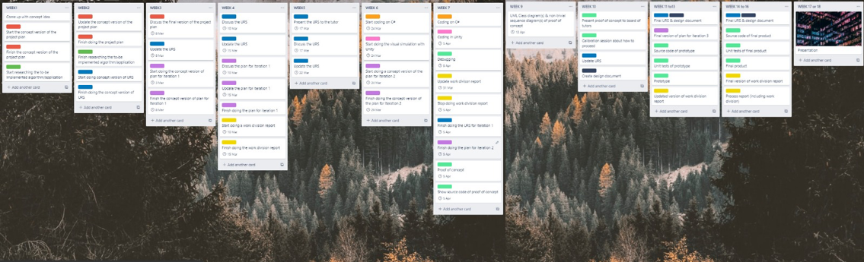

# Work distribution and planning

Text

# REFERENCES

1. Kuah, Chung W.C. – A Simulation Application Workbook. Project Core Phase. February 2020, Fontys.

2. Tedros, Adhanom G. - Tweet https://twitter.com/DrTedros/status/1226629008302931971. World Health Organization director, February 2020.

3. Collaborative article - Retrieved on February 2020, at en.wikipedia.org/wiki/Field_hospital

4. Weather information for Wuhan https://en.climate-data.org/asia/china/hubei/wuhan-2629/.

5. Yoshiaki N. et al. - Two Japan Evacuees Get Coronavrus After First Testing Negative. Retrieved on February 2020, at https://www.bloomberg.com/news/articles/2020-02-11/two-japan-evacuees-getcoronavirus-after-first-testing-negative